Biddulph and District Genealogy and Historical Society
The next meeting will be held on Monday 17th November2025 at 7.00pm
Talk by Eric Cox local historian and author
The American soldiers in Biddulph during WW2
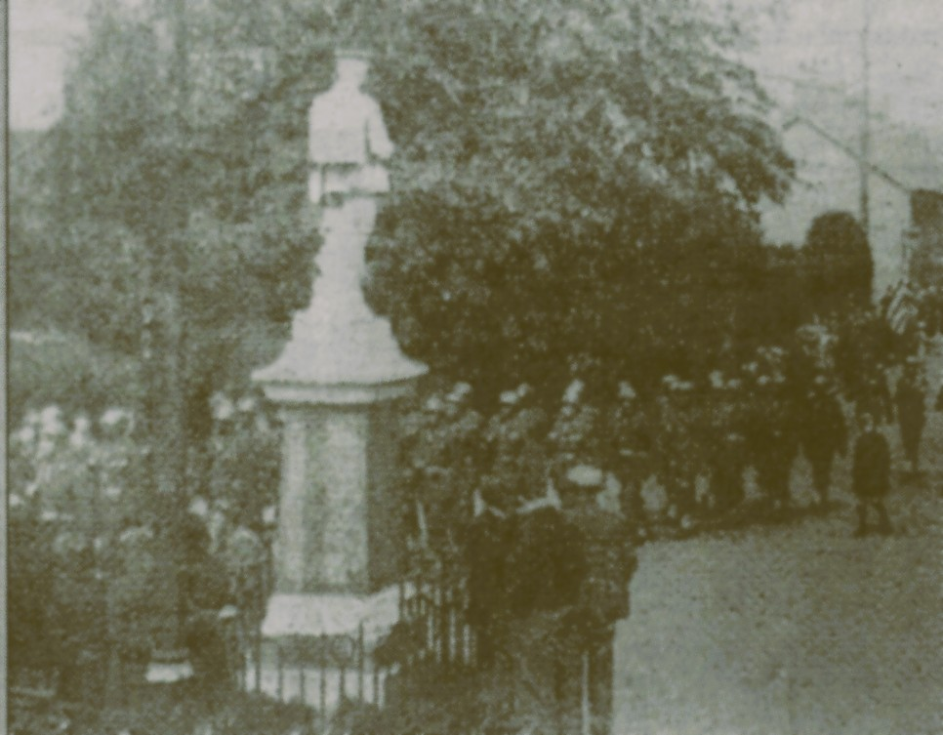
At the Biddulph Methodist Church – Victoria Centre, Station Road, Biddulph.
Members have free admission and guests are welcome at £3 each. Come and enjoy your local history.
Tea and Coffee will be served at the end of the meeting.

