Biddulph and District Genealogy and Historical Society
The next meeting will be held on Monday the 21st September 2026 at 7.00pm
Factory in the garden story of Emanuelli ice cream family at the Paddock Biddulph. Talk by Dominic Emanuelli
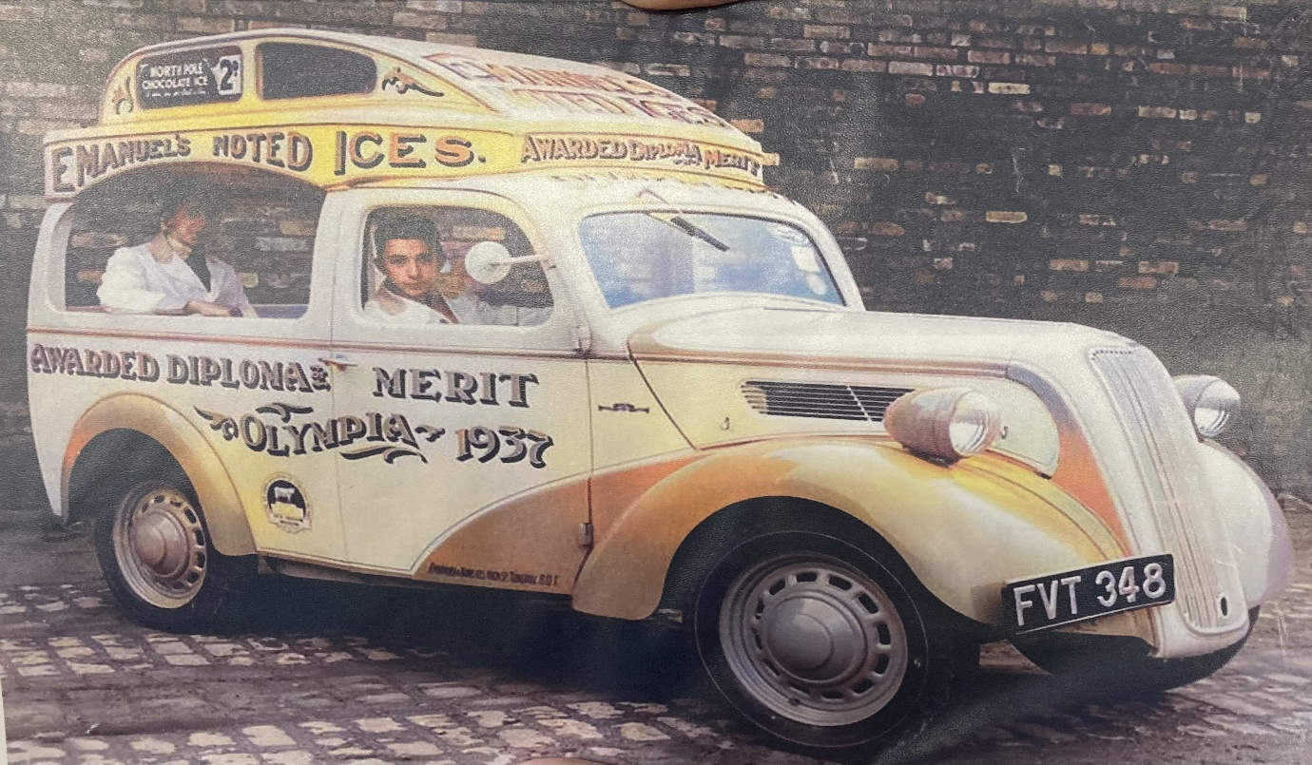
at Biddulph Methodist Church – Victoria Centre, Station Road, Biddulph.
Members have free admission and guests are welcome at £3 each. Come and enjoy your local history.
Tea and Coffee will be served at the end of the meeting.

