Biddulph and District Genealogy and Historical Society
The next meeting will be held on Monday 15th December 2025 at 7.00 pm.
TALES from the BIDDULPH TOWN CRIER JOHN ROBINSON
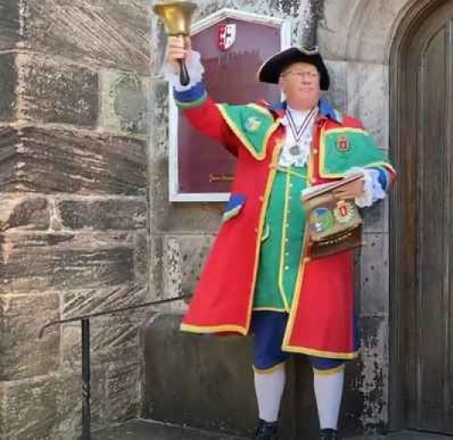
At Biddulph Methodist Church – Victoria Centre, Station Road, Biddulph.
Members have free admission and guests are welcome at £3 each. Come and enjoy your local history.
Tea and Coffee will be served at the end of the meeting.

