Biddulph and District Genealogy and Historical Society
The Annual General Meeting will be held on Monday 16th March at 7.00pm followed by Bridges of the Biddulph Valley talk by Michael Turnock and Elaine Heathcote
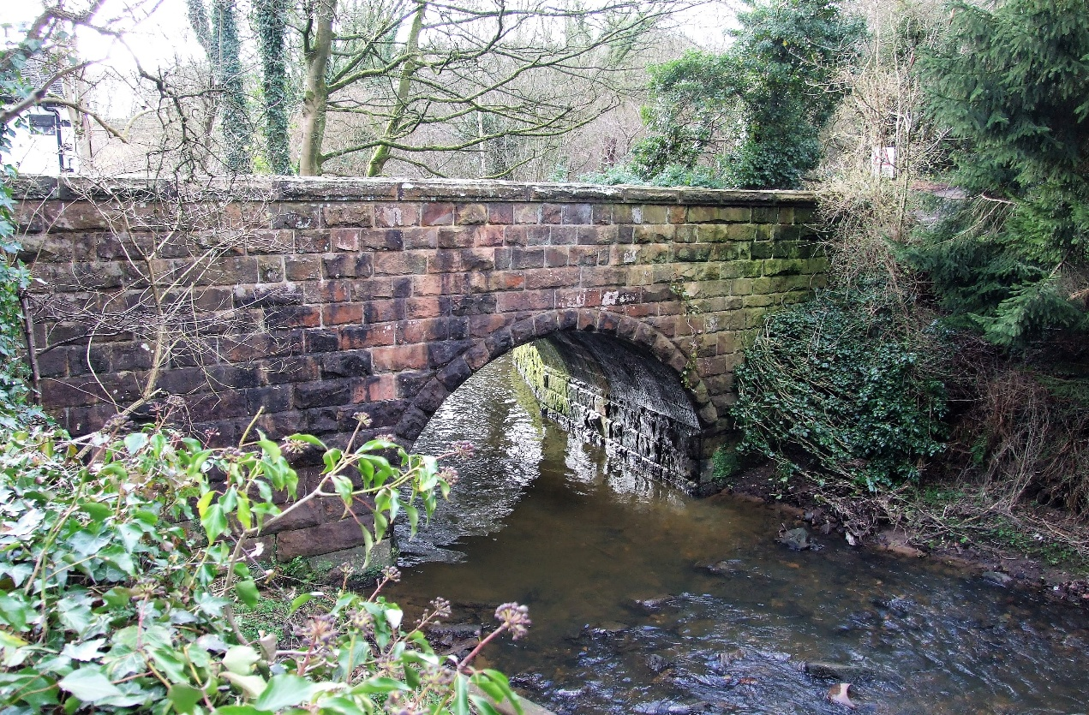
Biddulph Methodist Church – Victoria Centre, Station Road, Biddulph.
Members have free admission and guests are welcome at £3 each. Come and enjoy your local history.
Tea and Coffee will be served at the end of the meeting.

