Biddulph and District Genealogy and Historical Society
The next meeting will be held on Monday 16th February 2026 at 7.00pm.
Bill Ridgway- Geraldine Outhwaite and Friends
Present their Play Reading Arnold and Marguerite
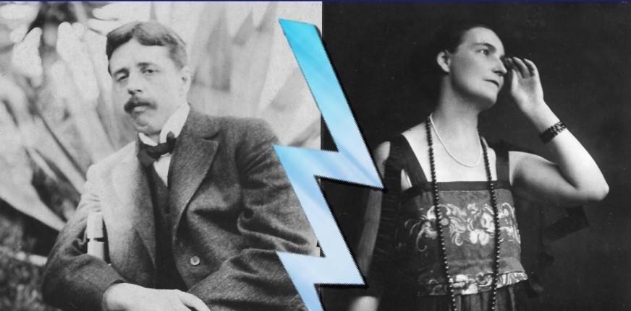
Tale of Arnold Bennett’s marriage
At Biddulph Methodist Church – Victoria Centre, Station Road, Biddulph.
Members have free admission and guests at £3 each.
Tea and Coffee will be served at the end of the meeting.

